Optimization in Synthesis

1. If-Else Statements in Verilog
if-else statements are a fundamental part of behavioral modeling, used for conditional execution within procedural blocks like always and initial.
Syntax:
Verilog
if (condition) begin
// Code block if condition is true
end else begin
// Code block if condition is false
end
The else portion is optional. A begin ... end block is necessary only if there are multiple statements within the conditional branch.
Nested If-Else:
Multiple conditions can be checked sequentially using nested if-else if constructs.
Verilog
if (condition1) begin
// Code for condition1
end else if (condition2) begin
// Code for condition2
end else begin
// Code if no conditions are met
End

2. Inferred Latches in Verilog
An inferred latch occurs when a synthesis tool creates a latch where none was intended. This happens when a variable in a combinational always block is not assigned a value in all possible execution paths. Latches are level-sensitive and can cause unexpected timing and race conditions, which is generally undesirable in synchronous designs.
Example of Latch Inference:
The following code will infer a latch because the output y is not assigned a value when sel is 0.
Verilog
module ex (
input wire a, b, sel,
output reg y
);
always @(a, b, sel) begin
if (sel == 1'b1)
y = a; // 'y' is unassigned if 'sel' is 0
end
endmodule
Solution:
To prevent latch inference, ensure all possible paths assign a value to the output. This can be done by adding a default assignment or a complete else clause.
Verilog
module ex (
input wire a, b, sel,
output reg y
);
always @(a, b, sel) begin
case(sel)
1'b1 : y = a;
default : y = 1'b0; // Default assignment prevents latch
endcase
end
endmodule

3. Labs for If-Else and Case Statements
Lab 1: Incomplete If Statement
This example will infer a latch because y is only assigned when i0 is true.
Verilog
module incomp_if (input i0, input i1, input i2, output reg y);
always @(*) begin
if (i0)
y <= i1;
end
endmodule

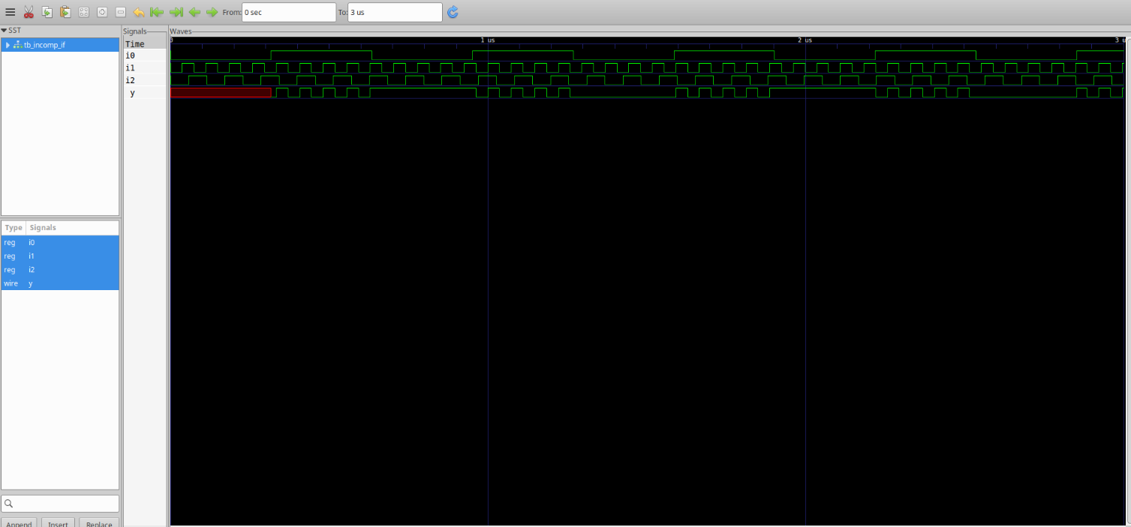
Lab 2: Synthesis Result of Lab 1
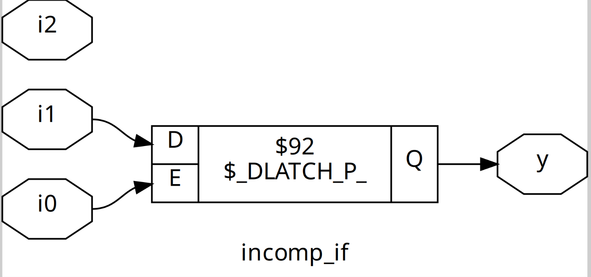
Lab 3: Nested If-Else
This code will also infer a latch if both i0 and i2 are false, as y would be unassigned.
Verilog
module incomp_if2 (input i0, input i1, input i2, input i3, output reg y);
always @(*) begin
if (i0)
y <= i1;
else if (i2)
y <= i3;
end
endmodule
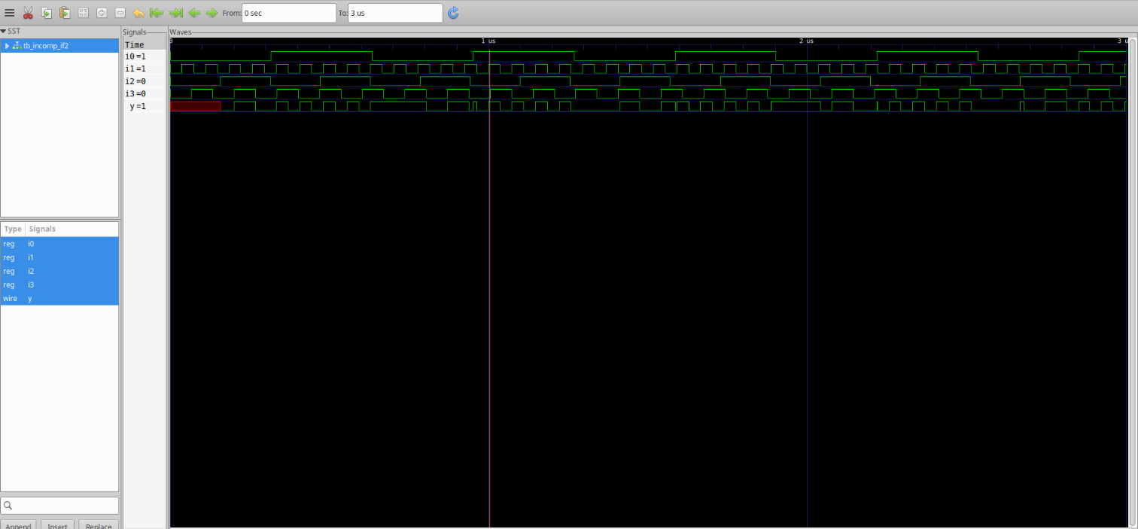
Lab 4: Synthesis Result of Lab 3
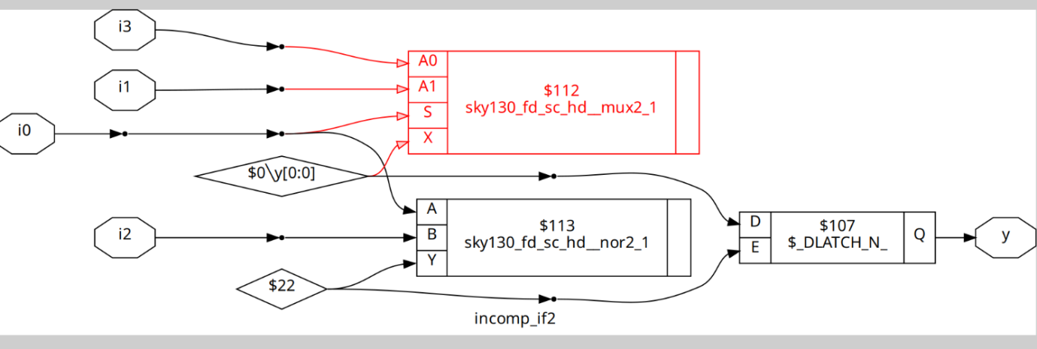
Lab 5: Complete Case Statement
This case statement is synthesizable as combinational logic because the default case ensures y is always assigned.
Verilog
module comp_case (input i0, input i1, input i2, input [1:0] sel, output reg y);
always @(*) begin
case(sel)
2'b00 : y = i0;
2'b01 : y = i1;
default : y = i2;
endcase
end
endmodule
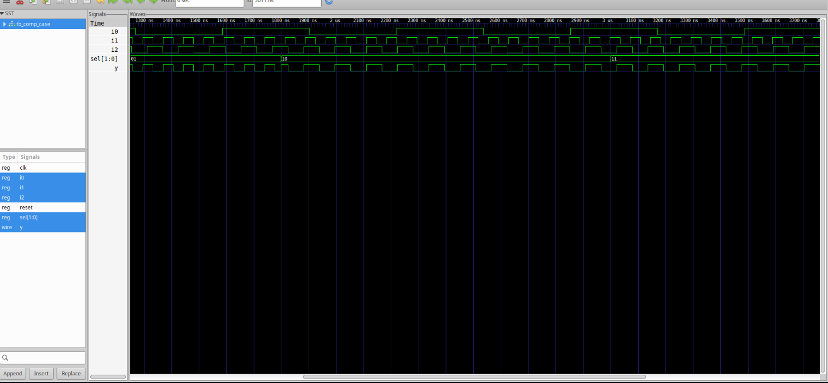
Lab 6: Synthesis Result of Lab 5
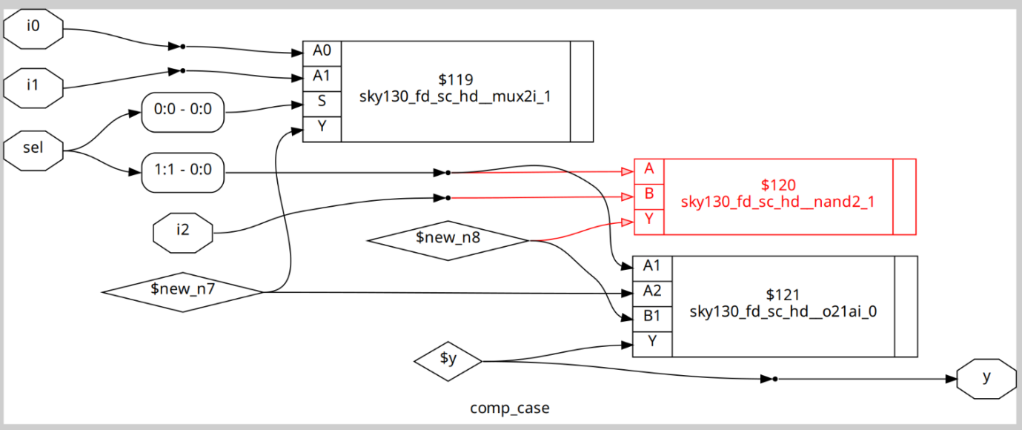
Lab 7: Incomplete Case Handling
The use of wildcards (?) can be tricky. This code will infer a latch because it doesn't handle all possible sel values (e.g., 2'b11), as the 2'b1? case only covers two of the four possibilities.
Verilog
module bad_case (
input i0, input i1, input i2, input i3,
input [1:0] sel,
output reg y
);
always @(*) begin
case(sel)
2'b00: y = i0;
2'b01: y = i1;
2'b10: y = i2;
2'b1?: y = i3; // The case for 2'b11 is not explicitly handled, leading to a latch
endcase
end
endmodule
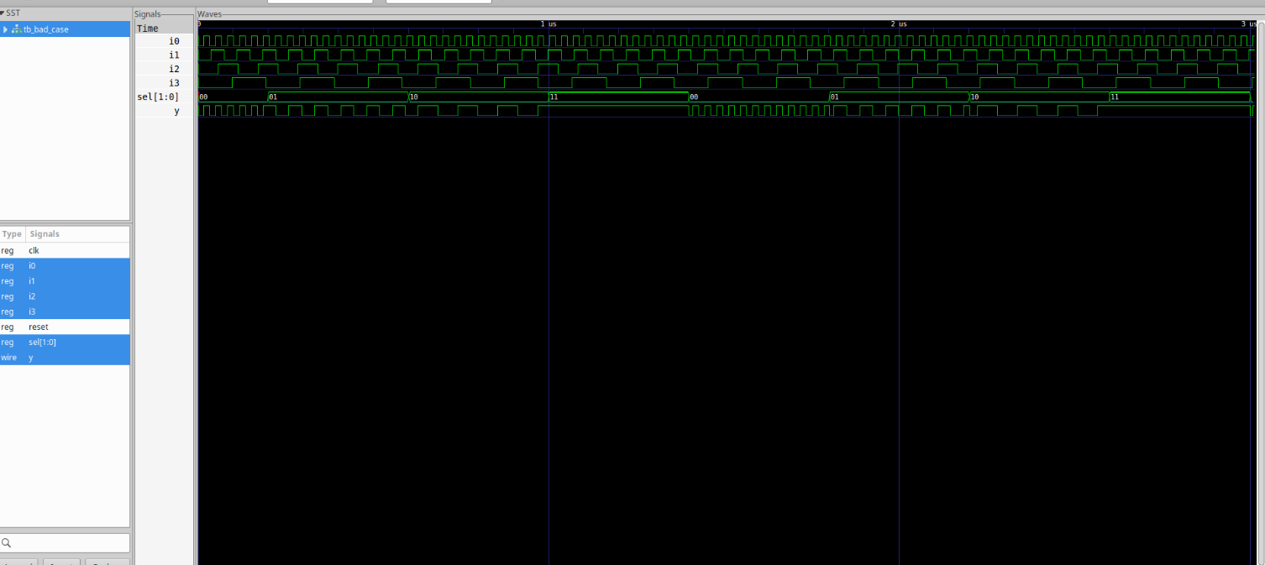
Lab 8: Partial Assignments in Case
This code will infer a latch for y because it is not assigned a value in the 2'b01 case, and for x because it is not assigned a value in the 2'b01 case.
Verilog
module partial_case_assign (
input i0, input i1, input i2,
input [1:0] sel,
output reg y, output reg x
);
always @(*) begin
case(sel)
2'b00: begin
y = i0;
x = i2;
end
2'b01: y = i1; // 'x' is unassigned
default: begin
x = i1;
y = i2;
end
endcase
end
endmodule

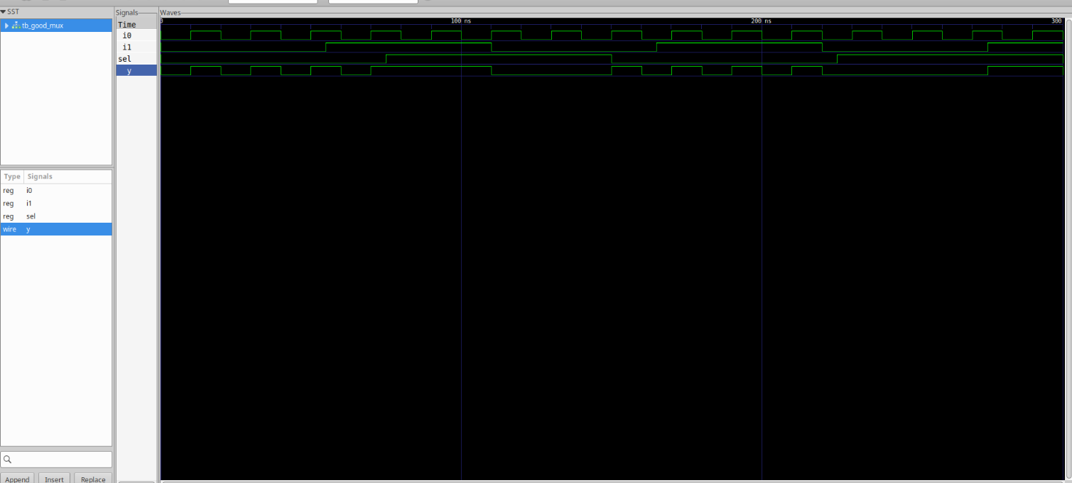

4. For Loops in Verilog
A for loop is used to execute a block of code multiple times. In synthesis, for loops are only synthesizable if the number of iterations is fixed at compile time. They are commonly used for creating repeated structures.
Example: 4-to-1 MUX Using a For Loop
This code uses a for loop to implement a 4-to-1 multiplexer by iterating through the data inputs.
Verilog
module mux_4to1_for_loop (
input wire [3:0] data, // 4 input lines
input wire [1:0] sel, // 2-bit select
output reg y // Output
);
integer i;
always @(data, sel) begin
y = 1'b0;
for (i = 0; i < 4; i = i + 1) begin
if (i == sel)
y = data[i];
end
end
endmodule

5. Generate Blocks in Verilog
A generate block is a powerful construct used to create multiple instances of a module or logic at compile time. It is typically combined with a for loop and the genvar keyword to create repetitive, scalable hardware.
Example:
This code uses a generate block to instantiate four identical and_gate modules.
Verilog
genvar i;
generate
for (i = 0; i < 4; i = i + 1) begin : gen_loop
and_gate and_inst (.a(in[i]), .b(in[i+1]), .y(out[i]));
end
endgenerate

6. What is an RCA (Ripple Carry Adder)?
A Ripple Carry Adder (RCA) is a digital circuit that adds binary numbers by chaining a series of full adders. The carry-out from each full adder stage is connected to the carry-in of the next, creating a ripple effect. This simple design is easy to implement but can suffer from significant propagation delay as the number of bits increases.

7. Labs on Loops and Generate Blocks
Lab 9: 4-to-1 MUX Using For Loop
This example is a re-written version of the 4-to-1 MUX using a for loop, demonstrating how repetitive logic can be coded efficiently.
Verilog
module mux_generate (
input i0, input i1, input i2, input i3,
input [1:0] sel,
output reg y
);
wire [3:0] i_int;
assign i_int = {i3, i2, i1, i0};
integer k;
always @(*) begin
for (k = 0; k < 4; k = k + 1) begin
if (k == sel)
y = i_int[k];
end
end
endmodule
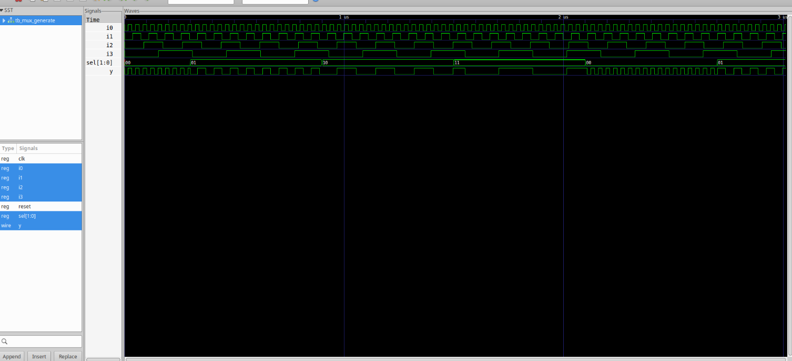
Lab 10: 8-to-1 Demux Using Case
This code implements an 8-to-1 demultiplexer using a case statement, a clear and straightforward approach for this type of logic.
Verilog
module demux_case (
output o0, o1, o2, o3, o4, o5, o6, o7,
input [2:0] sel,
input i
);
reg [7:0] y_int;
assign {o7, o6, o5, o4, o3, o2, o1, o0} = y_int;
always @(*) begin
y_int = 8'b0;
case(sel)
3'b000 : y_int[0] = i;
3'b001 : y_int[1] = i;
3'b010 : y_int[2] = i;
3'b011 : y_int[3] = i;
3'b100 : y_int[4] = i;
3'b101 : y_int[5] = i;
3'b110 : y_int[6] = i;
3'b111 : y_int[7] = i;
endcase
end
endmodule
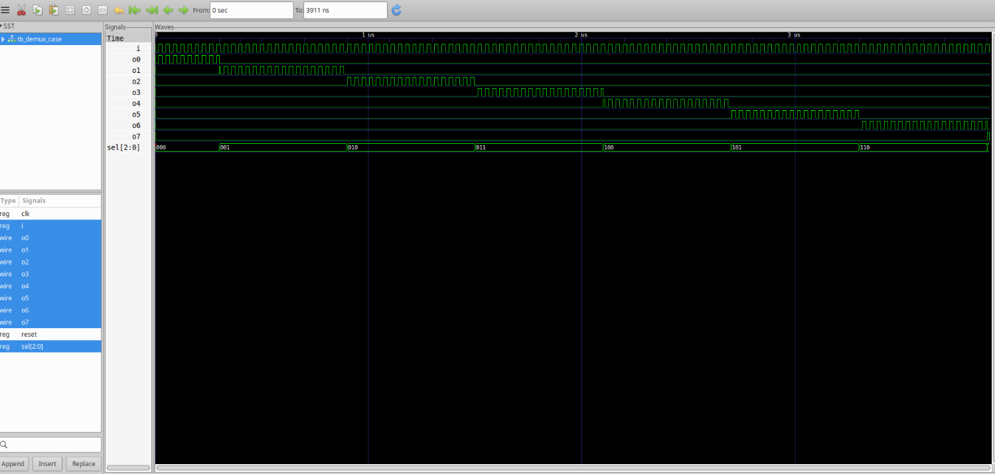
Lab 11: 8-to-1 Demux Using For Loop
This is an alternative implementation of the 8-to-1 demultiplexer, using a for loop. It demonstrates how a loop can be used to model repetitive demultiplexer logic.
Verilog
module demux_generate (
output o0, o1, o2, o3, o4, o5, o6, o7,
input [2:0] sel,
input i
);
reg [7:0] y_int;
assign {o7, o6, o5, o4, o3, o2, o1, o0} = y_int;
integer k;
always @(*) begin
y_int = 8'b0;
for (k = 0; k < 8; k = k + 1) begin
if (k == sel)
y_int[k] = i;
end
end
endmodule
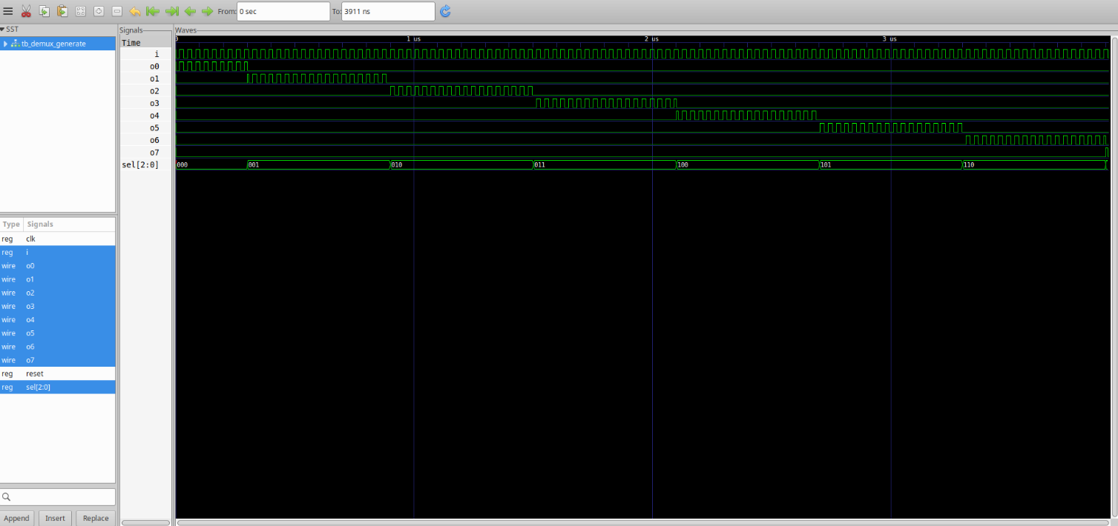
Lab 12: 8-bit Ripple Carry Adder with Generate Block
This example uses a generate block to instantiate multiple full adders to build an 8-bit Ripple Carry Adder, highlighting how to create a scalable, structured design.
Verilog
module rca (
input [7:0] num1,
input [7:0] num2,
output [8:0] sum
);
wire [7:0] int_sum;
wire [7:0] int_co;
genvar i;
generate
for (i = 1; i < 8; i = i + 1) begin
fa u_fa_1 (.a(num1[i]), .b(num2[i]), .c(int_co[i-1]), .co(int_co[i]), .sum(int_sum[i]));
end
endgenerate
fa u_fa_0 (.a(num1[0]), .b(num2[0]), .c(1'b0), .co(int_co[0]), .sum(int_sum[0]));
assign sum[7:0] = int_sum;
assign sum[8] = int_co[7];
endmodule

module fa (input a, input b, input c, output co, output sum);
assign {co, sum} = a + b + c;
endmodule
